Pls contact us :35007117@ qq.com

----------------------------------------------

Analog temperature sensor

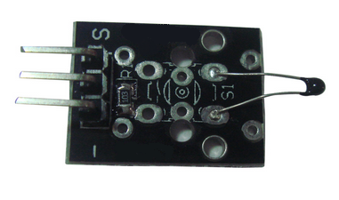

**Description:**  
  
The temperature sensor is a NTC thermistor  
Multi-point temperature measurement Measures temperatures: -55째C / +125째C  
Accuracy: + / - 0.5째C  
Material: mixed material  
Dimensions: 3 x 1.5 x 0.6cm  
Weight : 2g

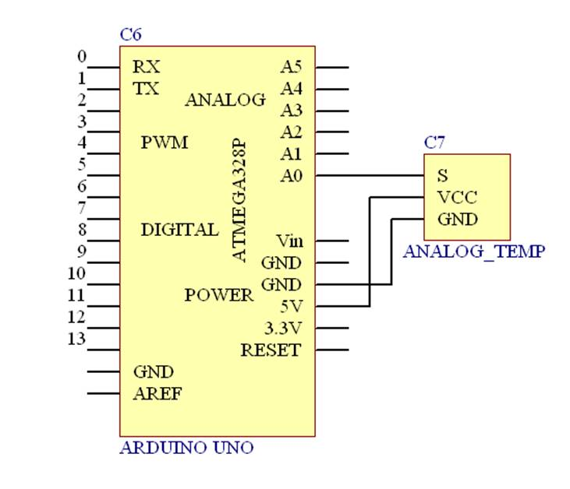

Test Code:

#include <math.h>

double Thermister(int RawADC) {

double Temp;

Temp = log(((10240000/RawADC) - 10000));

Temp = 1 / (0.001129148 + (0.000234125 + (0.0000000876741 * Temp * Temp ))* Temp );

Temp = Temp - 273.15; // Convert Kelvin to Celcius

return Temp;

}

void setup() {

Serial.begin(9600);

}

void loop() {

Serial.print(Thermister(analogRead(0))); // display Fahrenheit

Serial.println("c");

delay(500);

}

Thermistor why can temperature measurement, because it combines the Steinhart-Hart thermistor equations, is the equation of in test code in the function, double Thermister (int RawADC), said here, here's a look at the results

.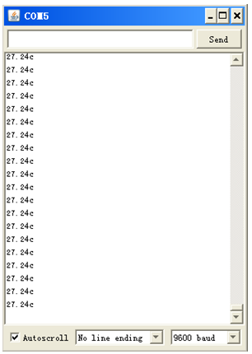

The above window shows the room temperature is now so much......

Well, here we touch it, see if there will be changes????

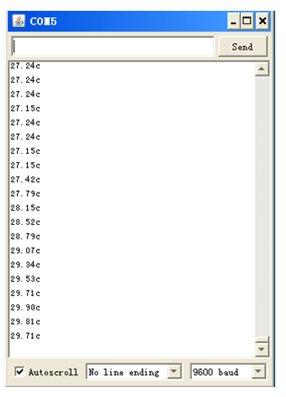

Test successfully completed